# Ahmed Adly - أحمد عدلي

## What is Ahmed Adly | أحمد عدلي?

**# Source**: **Chatgpt (GPT-5-Standard) at [8/27/2025]**

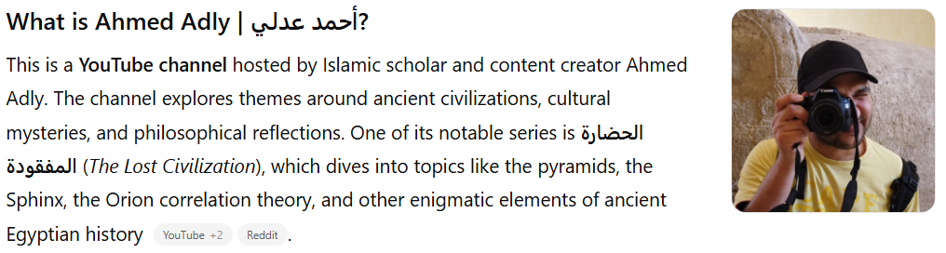

This is a **YouTube channel** hosted by Islamic scholar and content creator Ahmed Adly. The channel explores themes around ancient civilizations, cultural mysteries, and philosophical reflections. One of its notable series is **الحضارة المفقودة** (*The Lost Civilization*), which dives into topics like the pyramids, the Sphinx, the Orion correlation theory, and other enigmatic elements of ancient Egyptian history ([YouTube](https://www.youtube.com/%40AhmedAdly2?utm_source=chatgpt.com), [Reddit](https://www.reddit.com/r/Egypt/comments/105m6gk/your_opinions_on_ahmed_adlys_series_on_youtube/?utm_source=chatgpt.com)).

The playlist *الحضارة المفقودة* includes episodes such as “أهرامات وحزام أوريون” (*Pyramids and the Orion Belt*), “من نحت أبو الهول؟” (*Who Sculpted the Sphinx?*), and others that challenge conventional historical narratives ([YouTube](https://www.youtube.com/playlist?list=PL-07J7i9NNEXep1kgj6cRbHfbyl38WHJ3&utm_source=chatgpt.com)).

## Key Highlights

**# Source**: **Chatgpt (GPT-5-Standard) at [8/27/2025]**

* **Platform:** YouTube
* **Language:** Arabic
* **Focus:** Ancient civilizations, Egyptology, cultural history, philosophical insights
* **Popular Playlist:** *الحضارة المفقودة* (*The Lost Civilization*)
* **Tags:** Ancient Egypt, Lost Civilization, Pyramids, Philosophy, History

## Summary Table

**# Source**: **Chatgpt (GPT-5-Standard) at [8/27/2025]**

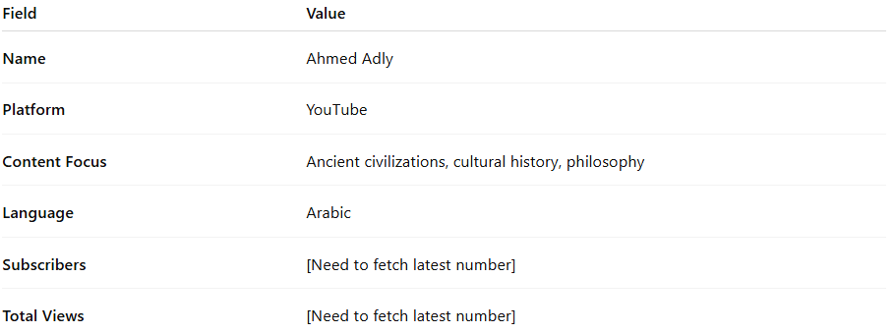

| **Field** | **Value** |
| --- | --- |
| **Name** | Ahmed Adly |
| **Platform** | YouTube |
| **Content Focus** | Ancient civilizations, cultural history, philosophy |
| **Language** | Arabic |
| **Subscribers** | [Need to fetch latest number] |
| **Total Views** | [Need to fetch latest number] |